**Day 28**





**“Web Development + Security”**

**CSS Object-fit and Object-cover:**

**What is object-fit?**

Object-fit defines how the content (like <img> or <video>) should be resized to fit its container. It works only on replaced elements (like <img>, <video>, <canvas>).

**Syntax:**

object-fit: value;

**Common values:**

| **Value** | **Description** | **Visual Result** |
| --- | --- | --- |
| **fill** (default) | Image stretches to fill the box, may get distorted | Image may look squished |
| **contain** | Image fits *entirely* inside container, keeping aspect ratio | May leave empty space |
| **cover** | Image fills container, *cropping extra parts* to maintain aspect ratio | Best for backgrounds, profile pics |
| **none** | Image keeps original size | May overflow |
| **scale-down** | Like none or contain, whichever is smaller | Auto fit |

**Object-position**

Controls which part of the image stays visible (when cropping happens in cover mode).

A very basic example: without these properties

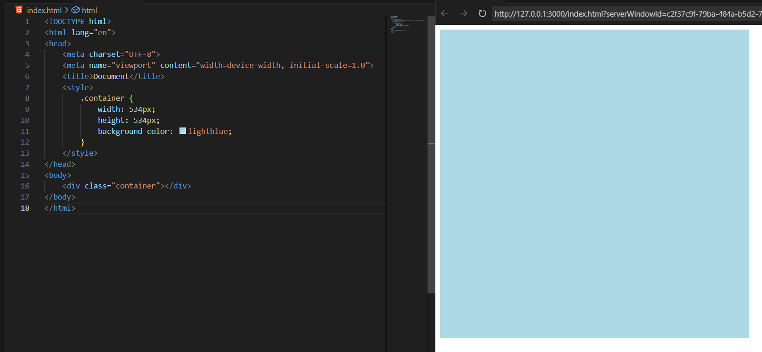

Now, we just add an image to it:

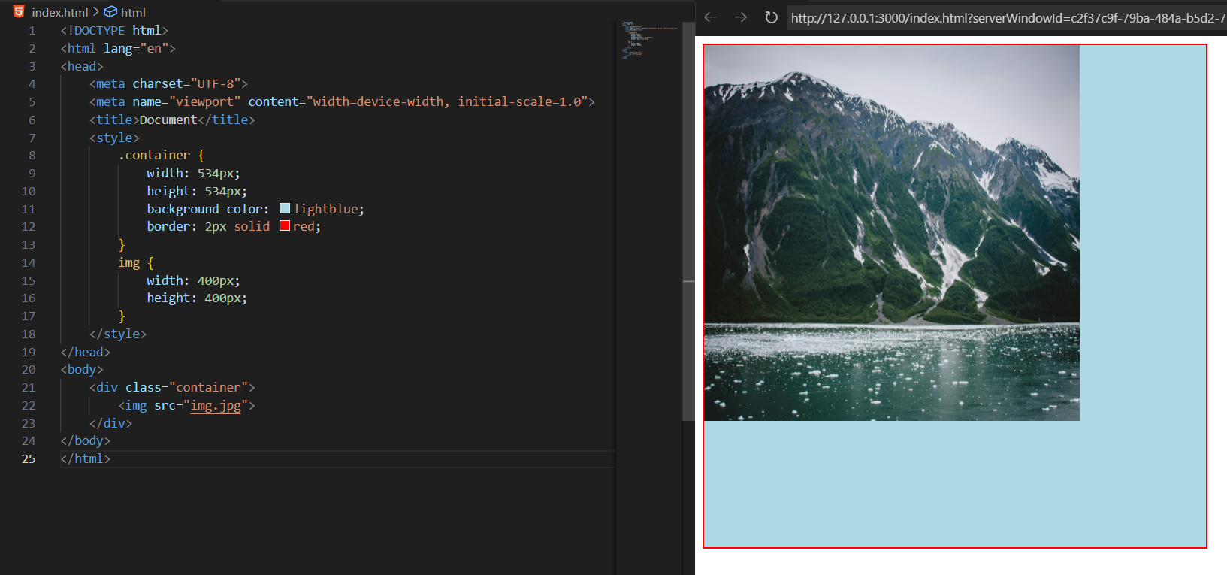

Clearly, we can see that image is not clear, so instead of finding the perfect height and width which we can assign to the image, we can use the object-fit.

Now, we will use the object-fit:cover, in case we allow the cropping of image in order to full fill the aspect ratio:

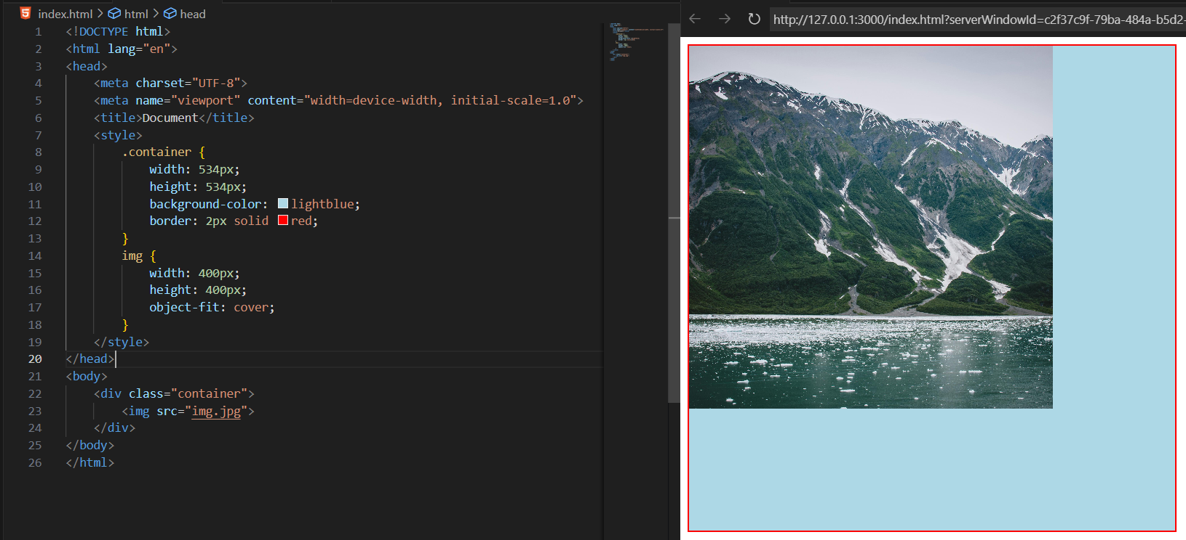

Now, we wish that the image should not get cropped, then we will use object-fit:contain, as shown below:

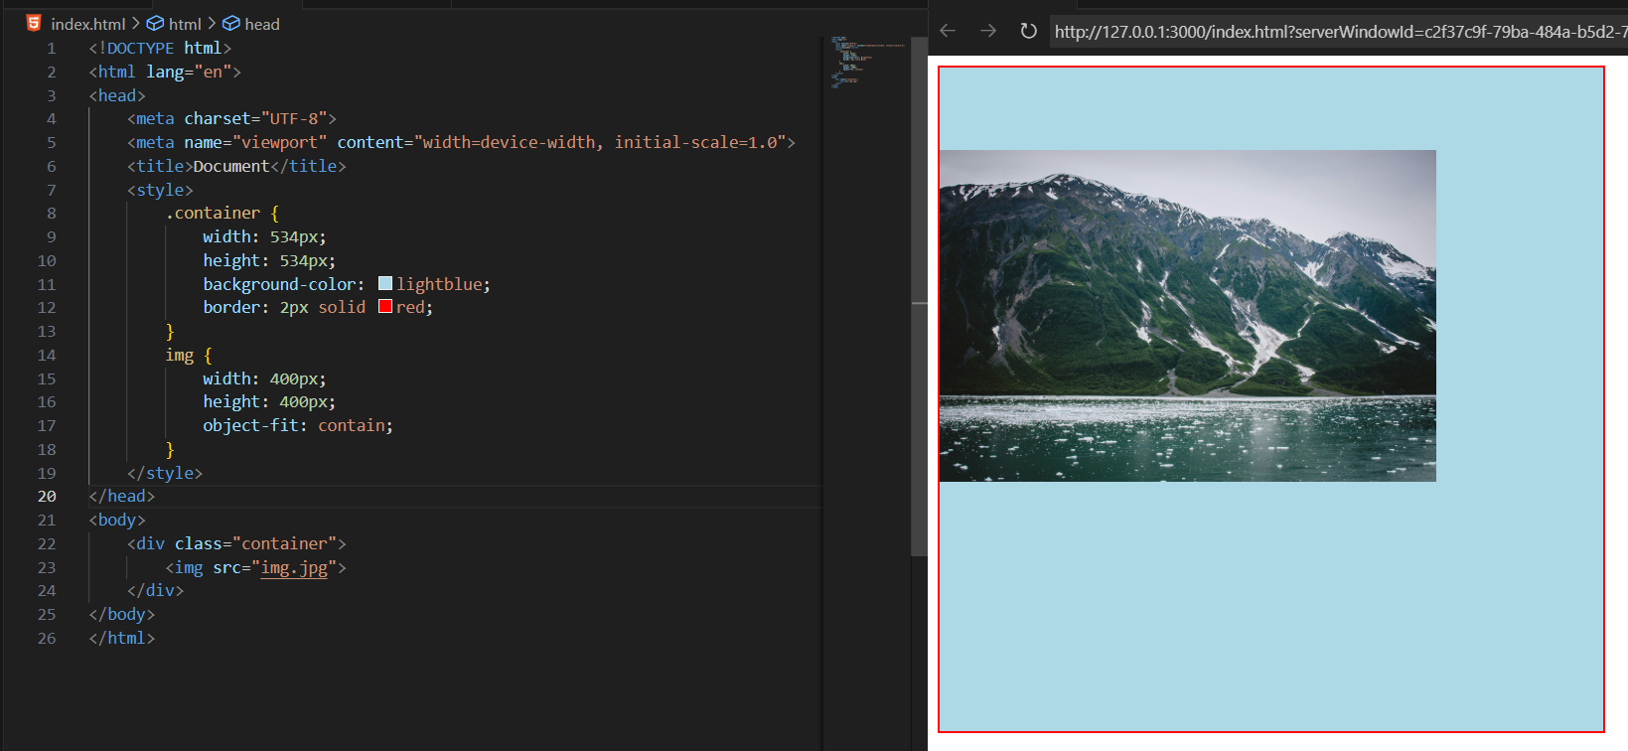

Now, in case we want that a certain position of the image should be shown, then we will use the property called object-position:

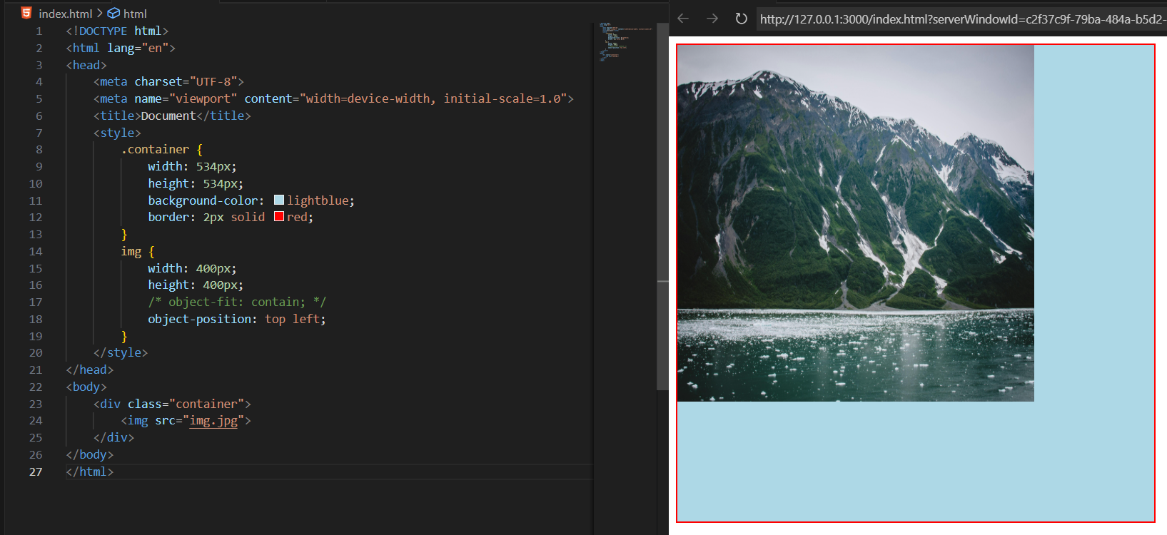

**CSS Filters:**

**What is a CSS Filter?**

The filter property lets you apply graphical effects to elements, such as blur, brightness, contrast, grayscale, sepia, hue rotation, and more.

You can apply filters to:

* <img>
* <video>
* <div> (with background images)
* Any HTML element

**Syntax:**

selector {

filter: filter-type(value);

}

**Common filter functions:**

| **Filter** | **Description** | **Example** |
| --- | --- | --- |
| blur(px) | Adds a blur effect | blur(5px) |
| brightness(%) | Adjusts brightness | brightness(150%) |
| contrast(%) | Adjusts contrast | contrast(120%) |
| grayscale(%) | Converts to grayscale | grayscale(100%) |
| sepia(%) | Adds warm brown tones | sepia(100%) |
| invert(%) | Inverts colors | invert(100%) |
| hue-rotate(deg) | Rotates colors on the hue wheel | hue-rotate(90deg) |
| saturate(%) | Increases/decreases color intensity | saturate(200%) |
| drop-shadow(x y blur color) | Adds a shadow behind an element | drop-shadow(5px 5px 10px gray) |

A basic code showing the image: without any filters

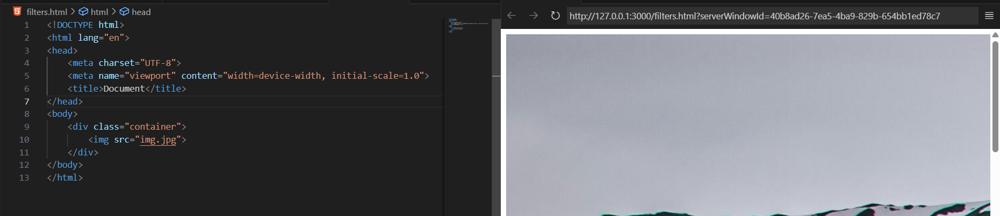

Now, we apply the blur():

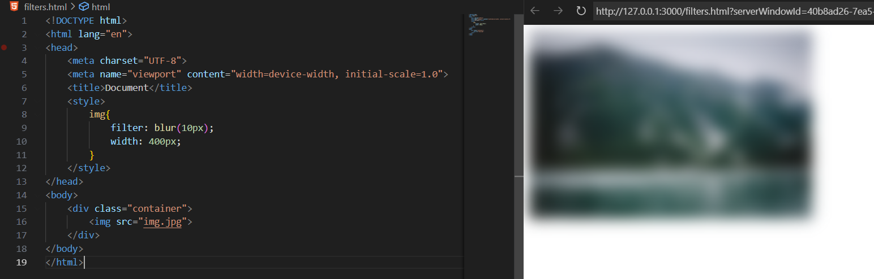

Now, we apply brightness():

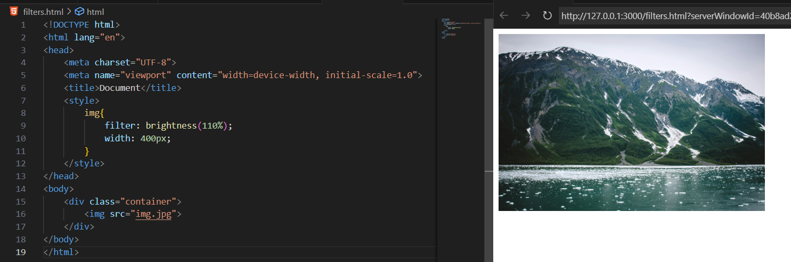

Now, we apply the grayscale():  
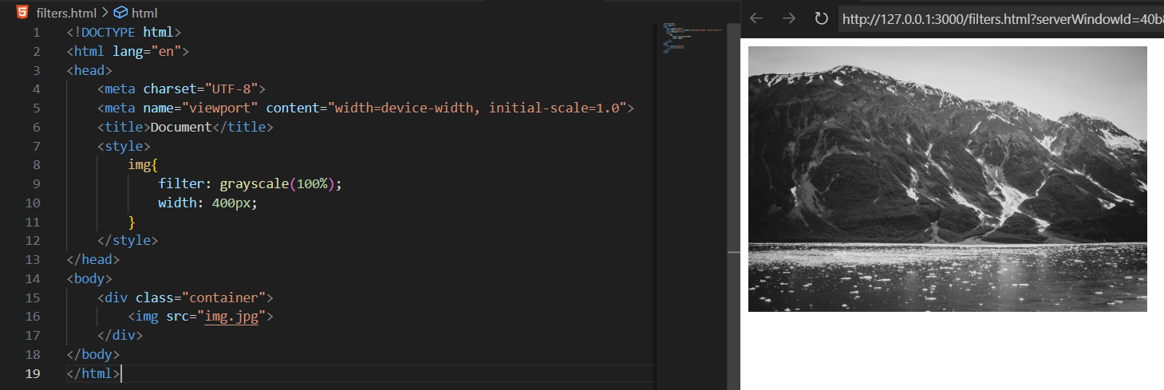

Now, we apply the invert(): 1 gives this, while 0 gives normal.  
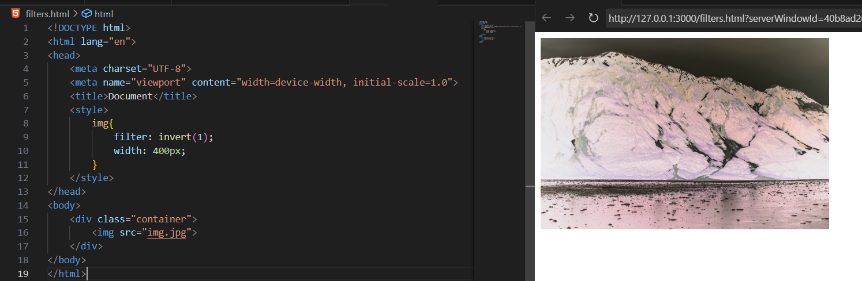

--The End--